RESOLUTION NO.__________

RE: CERTIFICATE OF APPROPRIATENESS UNDER THE
PROVISIONS OF THE ACT OF THE PENNSYLVANIA
LEGISLATURE 1961, JUNE 13, P.L. 282 (53
SECTION 8004) AND BETHLEHEM ORDINANCE NO.
3952 AS AMENDED.

The applicant proposes to install front window signage on Hotel Bethlehem Ice Cream Parlor replicating the hotel historic neon signage on its rooftop at 462 Main St.

NOW, THEREFORE, BE IT RESOLVED by the Council of the City of Bethlehem that a Certificate of Appropriateness is hereby granted for the proposal.

Sponsored by: (s)

(s)

ADOPTED BY COUNCIL THIS DAY OF

(s)
President of Council

ATTEST:

(s)
City Clerk

HISTORICAL & ARCHITECTURAL REVIEW BOARD

The applicant proposes to install front window signage on Hotel Bethlehem Ice Cream Parlor replicating the hotel historic neon signage on it’s rooftop at 462 Main St.

APPLICATION #4:
Walk In

Peter Kozicky
462 Main St.
Bethlehem, PA 18018

OWNER:

__________________________________________________________________________

The Board upon motion by Connie Glagola and seconded by Marsha Fritz adopted the proposal that City Council issue a Certificate of Appropriateness for the following:

- On the front sign, the center sign is to be reduced and in a creamy color.

2. “Hotel Bethlehem” is to be a neon sign to match the sign on the roof as shown on
the application.

3. The motion was unanimously approved.

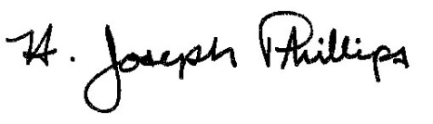 By:__H. Joseph Phillips___________

Title: __Historic Officer____________

Date of Meeting: October 3, 2018

